**Pattern Used:**

In my Scenario, the best one which suits the **Danger Alert Event** is **Observer Pattern.** The reason of using the defined pattern is because

* As when the Kids are playing, if any danger occurs or is going to happen it will automatically update the Parents/User.
* Even if the Kids are inside the house, i.e. an animal is present which may cause trouble so still their Parents will be informed by the above Pattern being used.
* Observer Pattern will update whenever the defined event occurs because it is used to **Observe** and then **notify** about what event took place.

**Use Cases where it can be used:**

Just like **Danger Alert System**, it can be relevant to other events too for Instance

* Location Tracking
* Health Updates
* Safety Zone, etc.

**Use Case Diagram: (Kids Monitoring System)**

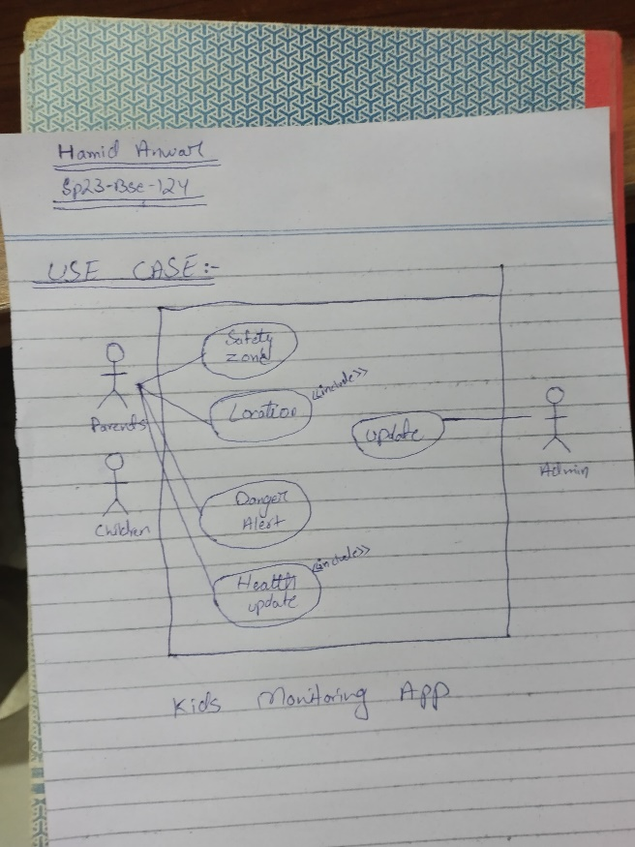

**Communication Diagram:**

